**BENCHMARKING**

**ALAMO**

**Premier Rent a Car**

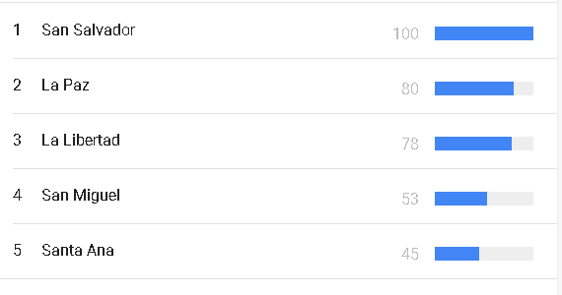

**Producto:**